

**COMPANY PROFILE**

**About Us**

IS601 Services Limited is a civil contracting company, with expertise in preventive security systems; civil/structural construction; facility management. The Company works with her clients to design, build, operate and maintain energy-efficient and environmentally-friendly facilities. The Company offers services in various sectors, such as food and beverage, pharmaceutical, industrial, energy and public sectors.

**History**

IS601 Services Limited is a contemporary services company providing services such as construction, perimeter barriers and securities and facilities management. Though IS601 was duly incorporated and registered by the Corporate Affairs Commission in the year 2017. We have evolved in the scope and delivery of our services to have in our clientele high net worth individuals, reputable multinational corporations and government agencies. IS601 is a fast growing company, with project presence in states of the federation.

**Business Strategy**

IS601 Services Limited identifies with the needs and aspirations of her clients and that of its business environments in the execution of it operations. Whilst also providing uncompromised budget based solutions.

**Our People**

Our team comprises highly qualified and experienced personnel, committed to giving our clients the best at any time. We look forward to being the example for a whole new definition of professionalism.

**Our Vision**

To be a renowned and foremost 21st century construction service company

**Our Values**

Quality, Integrity, Innovation and Commitment

**Our Services**

Our services include Perimeter barrier installation, Construction and facility management:

* Perimeter barrier systems
* Civil construction
* Facility inspection
* Facility management
* Consultation

**Business Philosophy**

Speed of Response, Accuracy and Clarity

Instant response- That’s what you need. That’s what you get. We can supply you with layouts,

proposals in any format such as on disk, on paper or direct to you by e-mail. Besides the

speed of response, clear, accurate and positive information – whether it is the specifications of

the items that we recommend and select to performance expectations is also essential. That’s

what you will receive. In fact we will demonstrate the same to you practically, so that you know

exactly what you will get.

Range – Types and Variants

We know that this is critical to your business to have just the right item that is functional, yet

merges perfectly with the décor that you have worked so hard to create. No more eyesores that detract from the impact of your designs. You want variety, compatibility, performance; and that is what you will get!

Input on Every Project on a Turnkey Basis.

All your projects are important. We supply the proposal detailing selection,

location, positioning, specifications, prices, performance and parameters. Literally, we offer a one-stop turnkey security solution.

State of the art, Upgradeable yet the most Cost Effective Solutions

We understand that it enhances your reputation to incorporate only the best technically and

financially. Hence we search and develop international tie-ups with the best in the field that are compatible with local physical conditions, yet are cost effective.

Long Term Reliability

We realize that this is imperative for your continued growth and reputation.

That’s what we call reliability.

**OUR SERVICES**

**A. ARCHITECTURALLY DESIGNED HIGH TENSILE STEEL PERIMETER BARRIERS**

These are high level aesthetic security front line barriers; functional at all levels of design and construction piece. Variants of these exist in manners of security levels- high security levels, medium security level, low security level. These fences are designed to be difficult to climb and difficult to cut. By design, they offer the first option clarity on security recovery and rescue.

**B. CLOSED CIRCUIT TELEVISION SYSTEM (CCTV)**

This is a Colour/Mono CCTV observation system. It is proposed to the monitoring of activities.

The system is divided into 3 main units

i. Video collection

ii. Video transmission

iii. Video management

* **Web Enabled Digital CCTV Systems**

This models a complex system as a function of the subsystems improved by technology, it emphasizes a system which unlike the normal CCTV, the new Internet Protocol Cameras records video signals which it digitizes using specialized encoder that controls on-board web server, allowing the Internet Protocol Camera to act as a network device, it captures video images to be viewed not only through an existing network but also through a web browser that can be accessed via internet, as such from any location outside the surveillance premises. In assessment, this is a proposed improvement by extrapolation.

The web enabled systems deliver secure video recording, archiving, retrieval and real time images of surveillance captured as well as flexibility to show both full time motion and still images from any location.

Using a secure user name and password, users simply log unto any web portal and assess the digital video from any camera at any branch or facility. Servers located in a secure location are designed to contain enough storage to constantly record any movement.

It only allows authorized personnel to assess chronologically stored video files via a Local Area Network (LAN) or Internet connection. Users have found that these systems provide superior security and functionality as well as enhancing emergency response to high-risk calls. Enhanced features allow remote diagnostic program checks for failures, guaranteeing system uptime is maintained at highest possible levels.

**Features**

* Can be logged unto from any remote location
* Receives notification by phone, pager and email of events triggered by activity or camera
* Secure feature allowing only administrations to assign users with access permission

to view specific cameras

* Alarm messages sent by email, pager, cell phones
* Can integrated, fire alarm, access control burglary alarm

Our software is based on Windows server

**C. ACCESS CONTROL EQUIPMENT**

This can also be integrated into the system to give alarm indication when a door is opened forcibly or otherwise.

Entry information can be stored in a P.C. for a call-up when required or printed out immediately. This is possible when cards or codes are used. The details of such information can include time of entry, date, entry point etc. Cards can come as magnetic (Swipe or insert), Proximity, Wiegand, Barcode, Touch, Hands free, Hand geometry etc. Cards can be personalized to carry such personal characteristics as PIN numbers, signature, thumb print, passport photograph etc.

A full-configured access control system can include facilities/software for I.D. card generation/printing. This can also be integrated into the CCTV system as described earlier

**D. BURGLAR ALARM SYSTEM**

We install a variety of Intruder Alarm Systems comprising Magnetic Contacts, Motion/Vibration Detectors, Pressure Mats, Passive Infra-Red, Sounders, Personal attack Buttons. These can be linked to a Tele-dialer to dial your telephone number and give a message that building is being intruded into.

Also available is the “auto dial” facility, which automatically signals the Police Station or any

three call-up stations of your choice, when there is an “alarm condition”.

**E. DOORPHONE AND ELECTRIC DOOR ACCESS SYSTEM**

This system also enables you to monitor and control movement into your premises. The Electric Door Access System (Releaser) facilitates the opening of your doors for visitors at the touch of a button.

**F. ELECTRIC FENCE**

An electric fence system consists of electric wires carrying high voltage electric pulses that provide a non-lethal shock to an intruder. Tampering with the fence, results in alarm activation.

***Why Electric Fence?***

The need for high level of security to deter is growing worldwide. Whereas in the past a security fence was merely a passive physical barrier, the reality of today’s world prescribes the use of active intrusion detection system that reacts to any intrusion attempts, preventing or delaying intruder access and that is not reliant on human surveillance.

***Who Uses Electric Fence?***

Private houses, housing estates, farms, industrial complexes, factories, warehouses, military installations and government facilities are all potential end users

***How does it work?***

In operation, high voltage (10,000 D.C. Voltage) pulse is sent down alternate wires every second. Intruders coming in contact with the wires are dealt with a sharp electric shock, which deters them from climbing or cutting the fence. “ANY ATTEMPT TO CUT OR CLIMB OVER THE FENCE WILL GENERATE AN ALARM, WHICH SOUNDS SIREN AT THE PREMISES”.

IS601 Services Limited is able to design and install for you a system that is tailored to meet your specific security needs at competitive cost.

**G. Intercom (voice and data)**

This is a stand-alone voice communications system coupled with data for use within a building or small collection of buildings, functioning independently of the [public telephone network](https://en.wikipedia.org/wiki/Public_switched_telephone_network) for easy, fast and effective dissemination of information as information delivery plays a very vital role in security

**H. Car park management solution**

This is the bringing together of an ANPR/LPR solution integrated with high resolution IP cameras, and access control system, to achieve a complete automatic car park solution. Mostly used in industries, estate, fleet management industry, et al.

**OUR TEAM**

**SEUN OKUTUBO**

SEUN, Okutubo Olorunfunmi is a result driven construction project manager who has had a combined civil and engineering construction industry experience of over 17years.

His diversified knowledge in different knowledge areas of project management has placed him at a vantage point over his peers in the industry, such experience that has made him to attain the status of Project Director and Coordinator on different projects in different sectors of the country.

He has worked on projects for State Governments, Private Sector Engineering and Civil projects and has collaborated on other projects as project consultant, such as Lagos State Model School Rehabilitation, Epe, Lagos. He had also in time past worked as Facility Manager at Osuntuyi Hospitals, Obanikoro Estate, Obanikoro, Lagos.

Notable projects which Engr Seun has successfully delivered include Adamawa State Government House Perimeter Fencing Project,Yola.

Asaba International Airport Perimeter Fencing Project.

Delta State Government House Internal fencing project Asaba.

Stephen Keshi Stadium, Asaba Olympic sized Swimming Pool fencing project.

Dangote Refinery internal Electric and Perimeter Fence project

Different projects ranging from fencing and demarcation of the Tennis Court TCC Resort, Ogere-Ogun State.

Seun is an alumni of Lagos State Polytechnic, Lagos where he bagged an Upper Credit in Building Technology and he is a member of various professional bodies, including National Institute of Building (NIOB), International Facilities Management Association, Facilities Management Professionals International, Industrial Safety Training Institute.

**BAKARE MICHAEL**

He holds a degree in Applied Physics from University of Lagos, Akoka, Lagos. He holds a Diploma in Computer science from Lagos City Computer College. He has a System Network certification. He has Web-Design Certificate from New Horizon. He holds Java Developer Certification from Karrox International. He was trained in Parallel System, South Africa ,on general extra low voltage system

Mr. Bakare Michael has more than 5 years technical know-how on different security solution like Access control management solution, Automated gate, CCTV (both analog and digital), Fire alarm system and suppressant system (both conventional and Addressable), Intercom, Electric fence, Car park solution, Turnstile and Barrier System. He has helped in design, implementation, upgrade and integration of various security solutions in different industries. His vast experience has distinguished him in any area of security solution provider. Some of the companies he handled there ELV projects includes (1) Nigeria Breweries-Costain, Lagos, Nigeria, (2) South Africa Breweries-SABmiller Interfact, Onitsha, (3)Glaxosmith klime (GSK)-Agbara, (4)Seplat Oil-Bourdillon, Ikoyi. (5) Maven Nigeria Ltd, MM2. and more

**AYOMIDE AKANBI**

Ayomide Akanbi is a Human Resources practitioner with competencies in Learning & Development and Organizational Behaviors. He has over ten (10) years cognitive experience in areas of Human Resource management and development, Human Capacity development, Process Improvement, Brand and Marketing as well as Corporate Strategy; within and outside the shores of Nigeria.

He has worked in different capacities within varying industries; Engineering Services, Information Management, Human Resources. Ayomide is a member of the Process Improvement Consult (PIC) Group.

His foray into the world construction and civil services began as an operations process manager in a top EPIC company. He has worked on different projects with the task to streamline and optimize efficiency within each project.

An Alumni of Ahmadu Bello University and The University of Manchester. He has worked on a number of projects in areas of Team Building & Management, Change Management and Process Improvement.

**WHO WE HAVE WORKED WITH?**

In the recent past, we have worked with various organizations on various projects

Nigeria including but not limited to:

* Heritage Park, landscape fencing. Osogbo, Osun state
* Jabi Lake Mall, perimeter fence. Abuja
* Landscape perimeter barrier. TCC Ogere, Ogun state
* Nnamdi Azikiwe International Airport, External perimeter barrier, Abuja
* Wings Office Complex, perimeter barrier. Victoria Island, Lagos
* Lekki Free Trade Zone, perimeter barrier. Ibeju-Lekki, Lagos
* The Palms Shopping Mall, Ibadan, Oyo state
* Agodi Botanical Garden, Ibadan, Oyo state
* Intafact Breweries, perimeter barrier. Sagamu, Ogun state
* Caverton Helicopter, Murtala Mohammed Airport, Lagos
* Streling Bank Plc
* SC Johnson, Isolo Lagos
* Hilti, Adeola Odeku Lagos
* Fragend Groups
* Other private development in Abuja, Ibadan, Lagos, Port Harcourt

Gallery of images of project executed and collaborated:

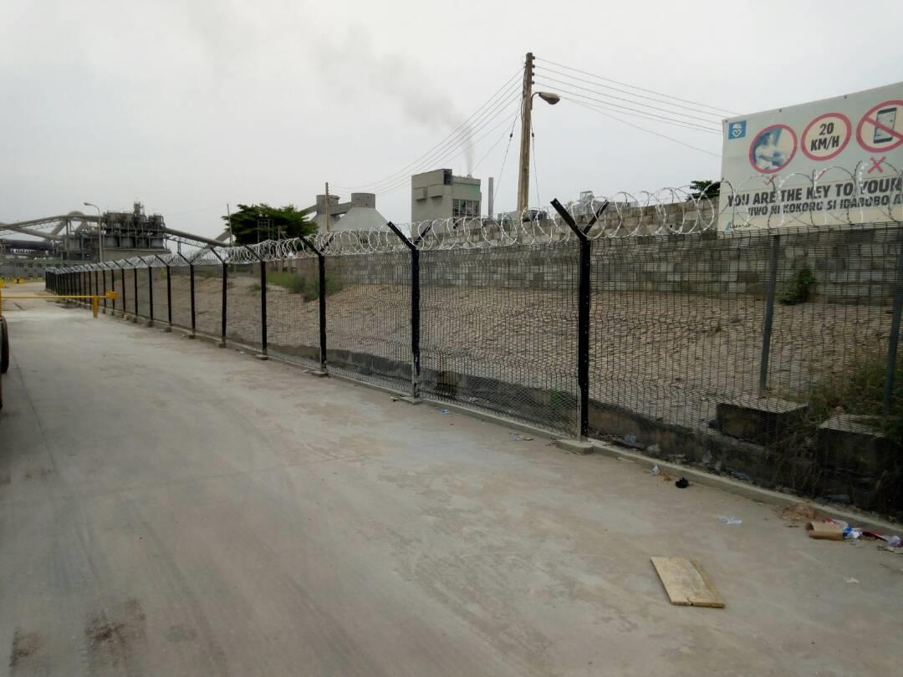

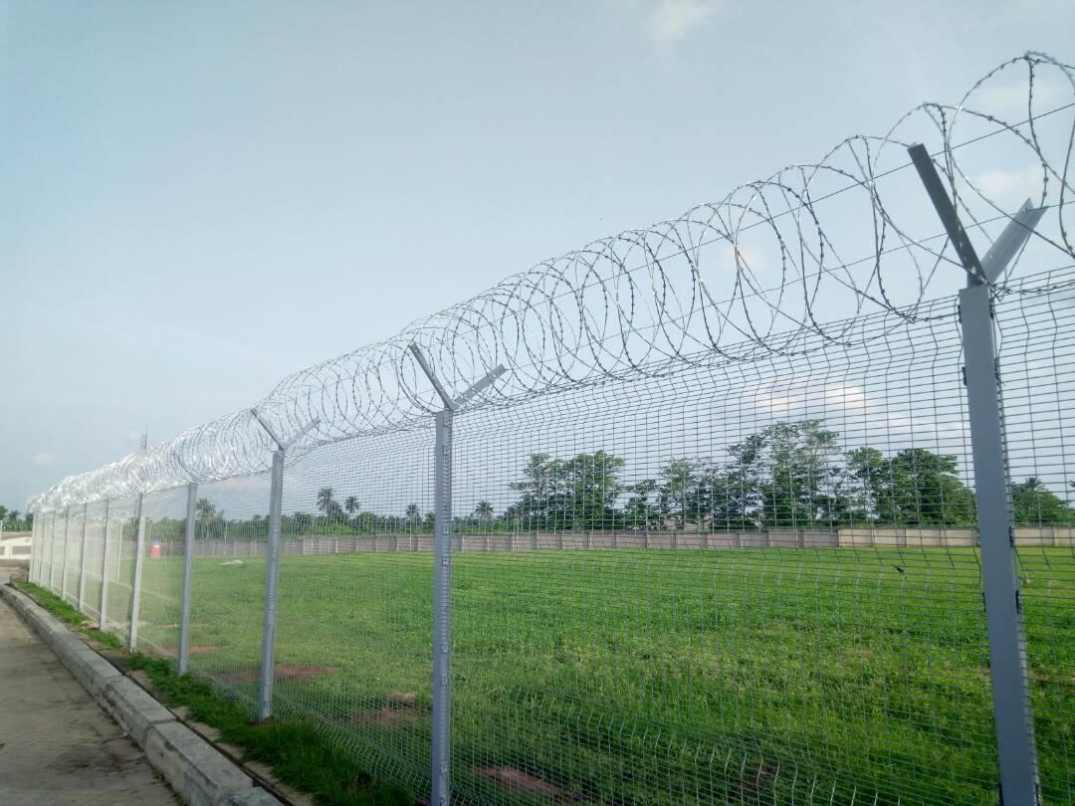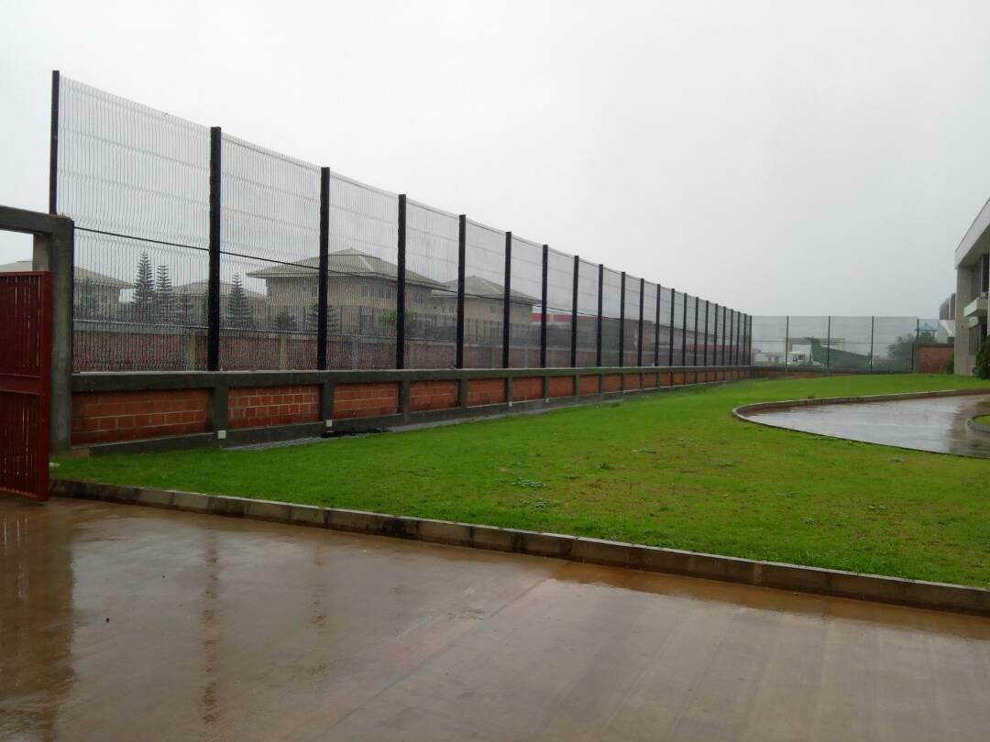

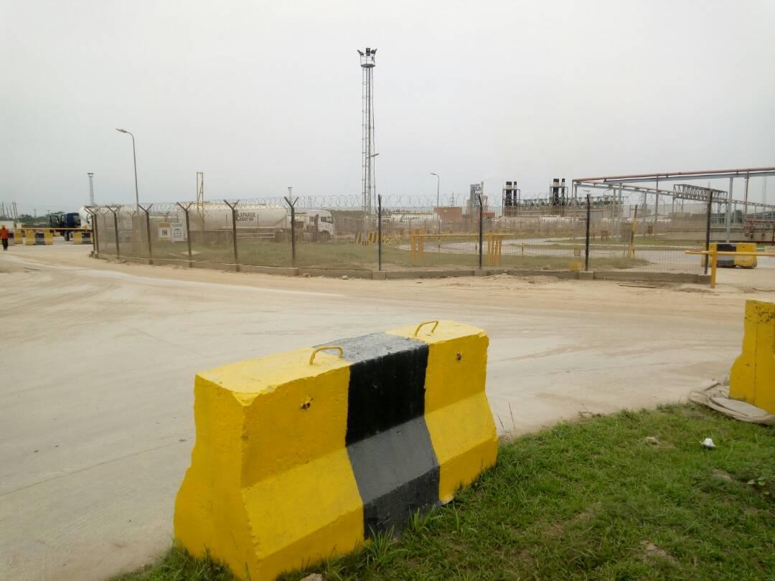

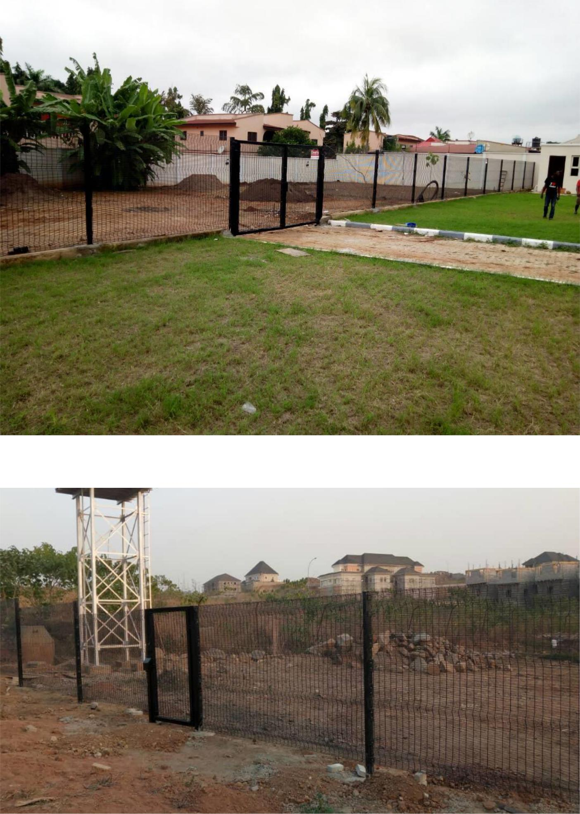

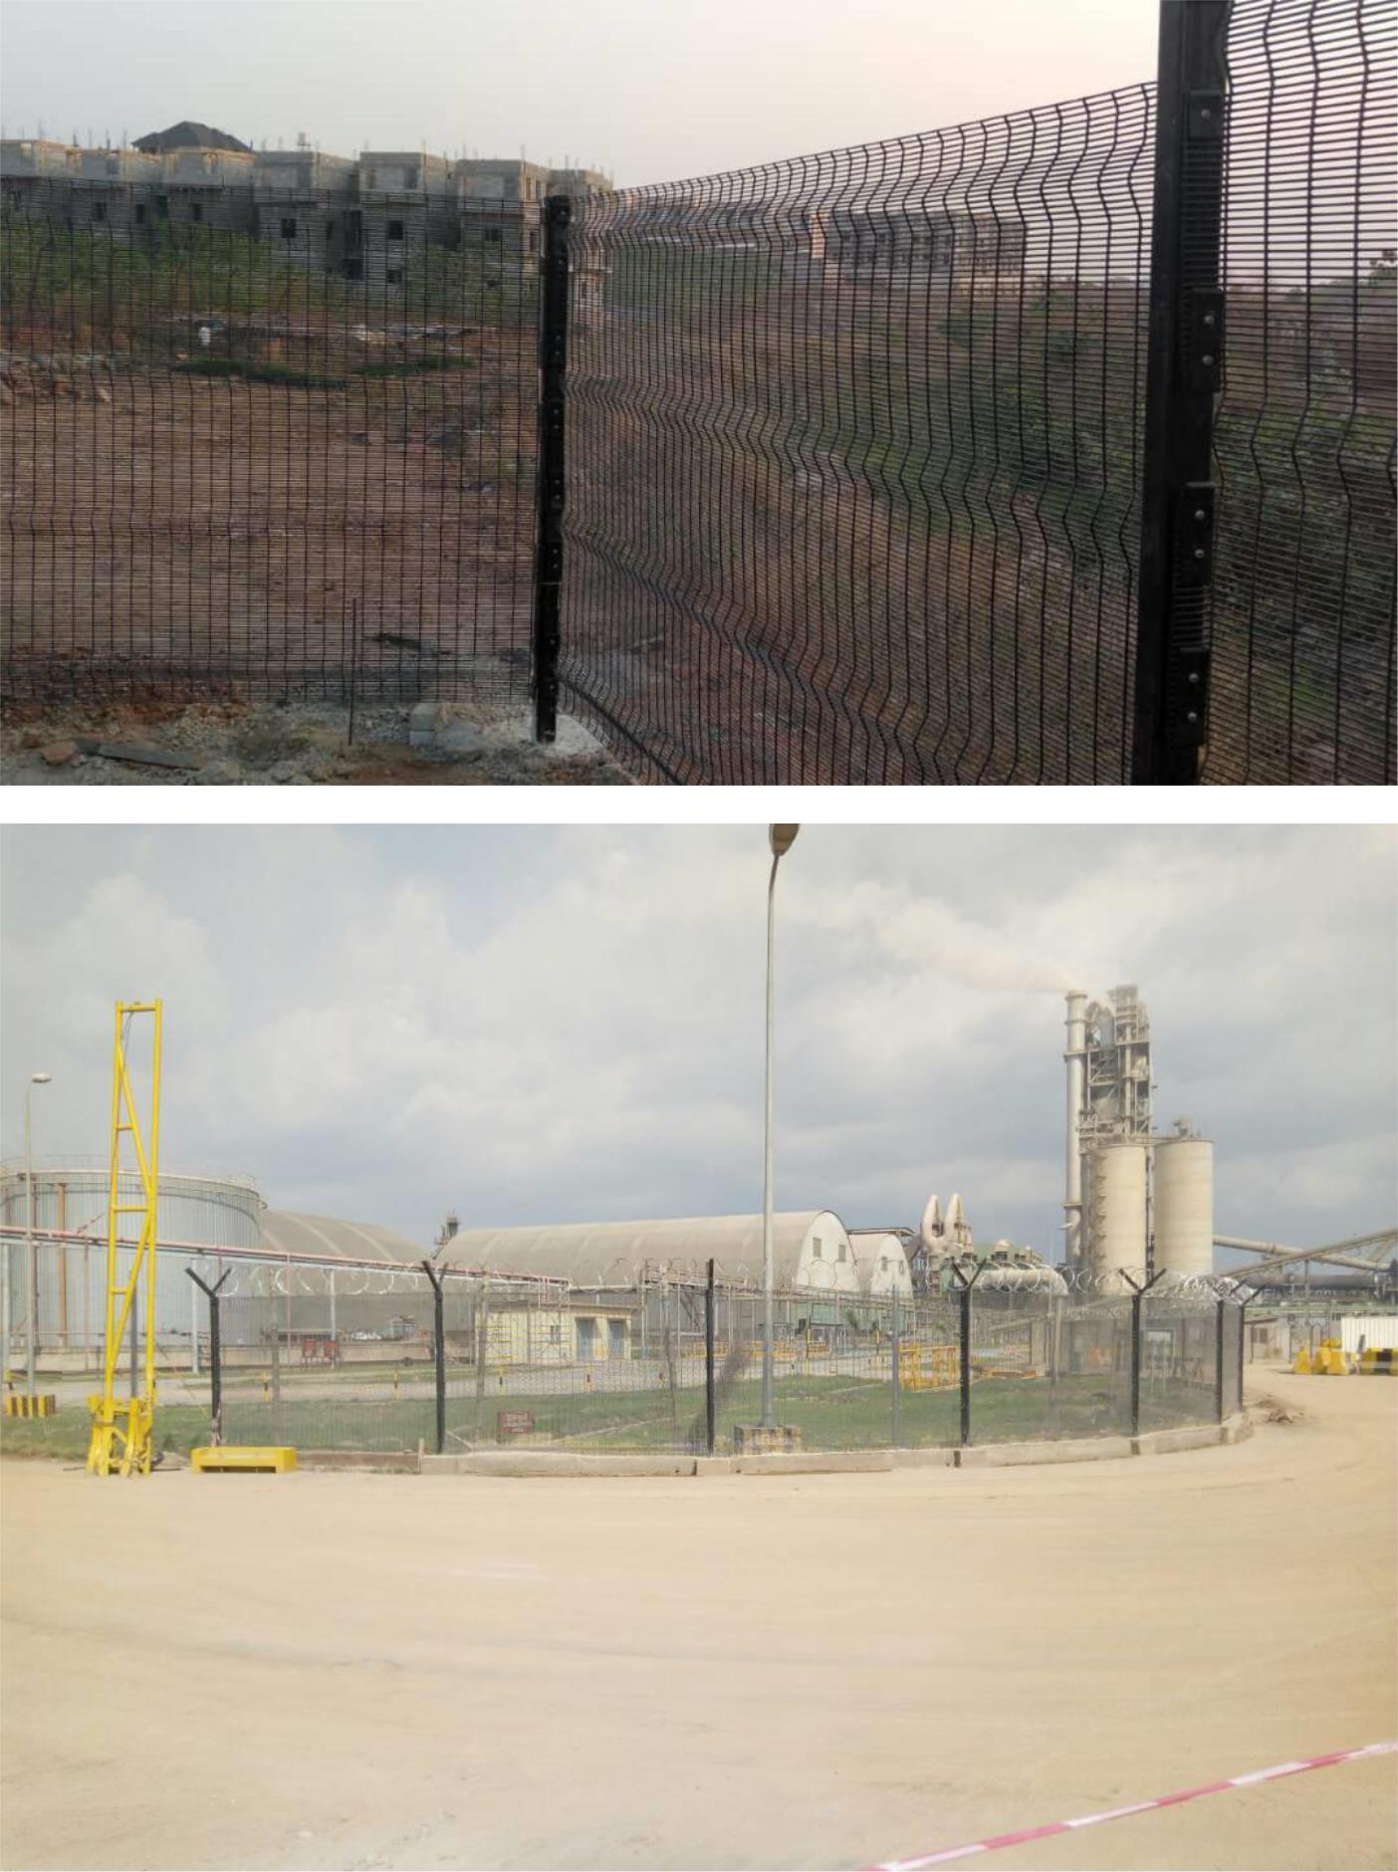

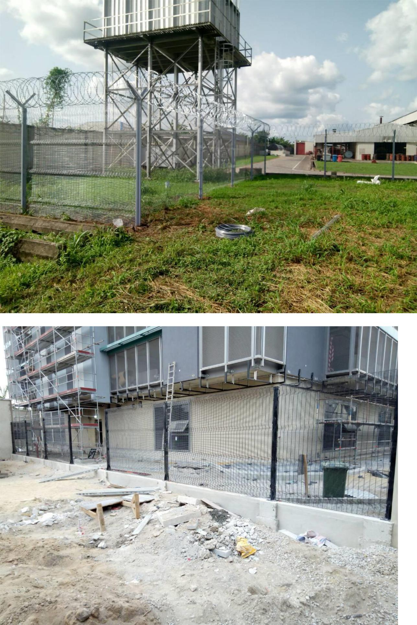

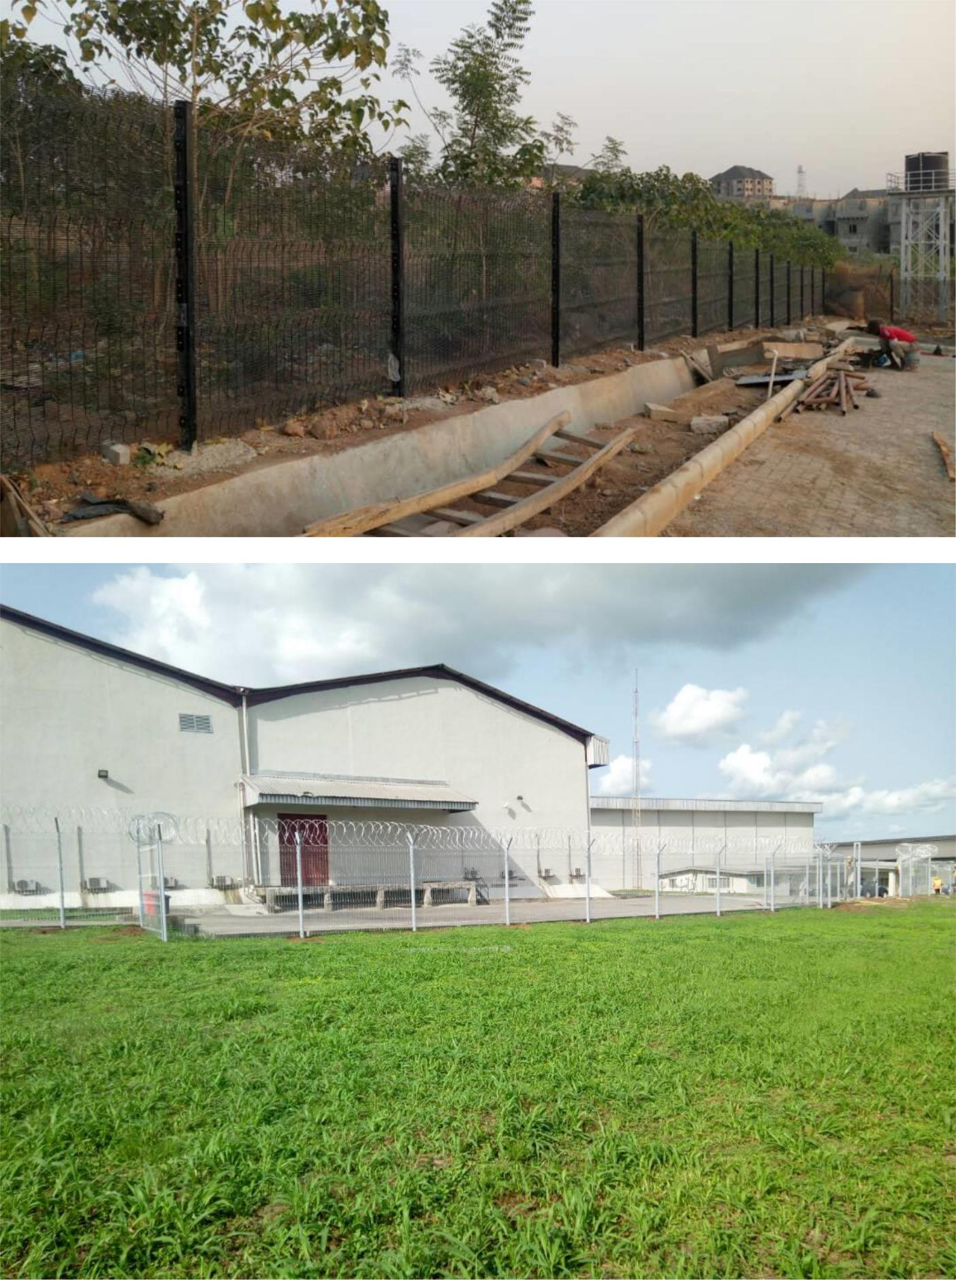

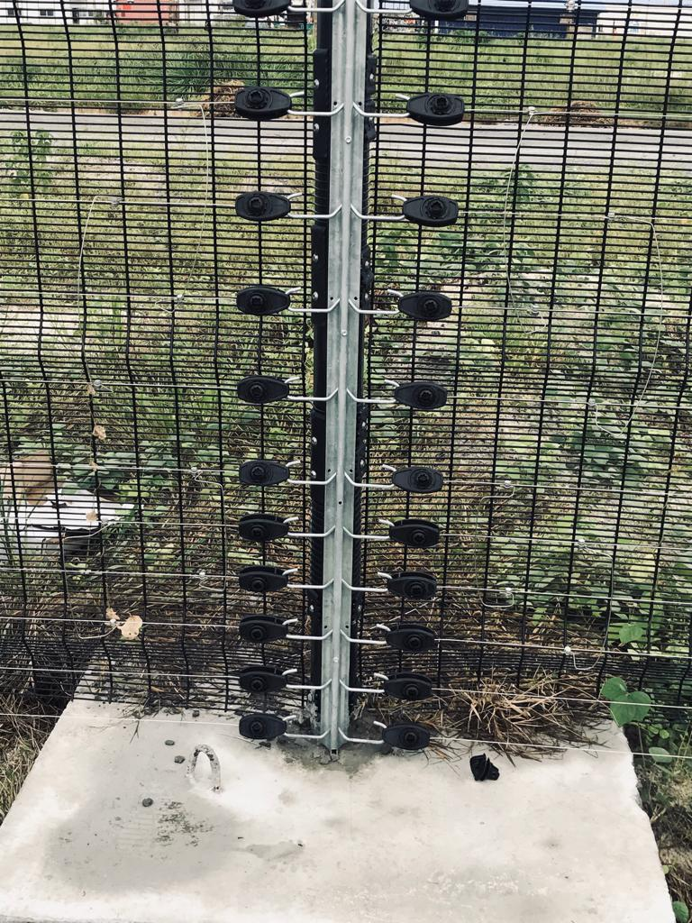

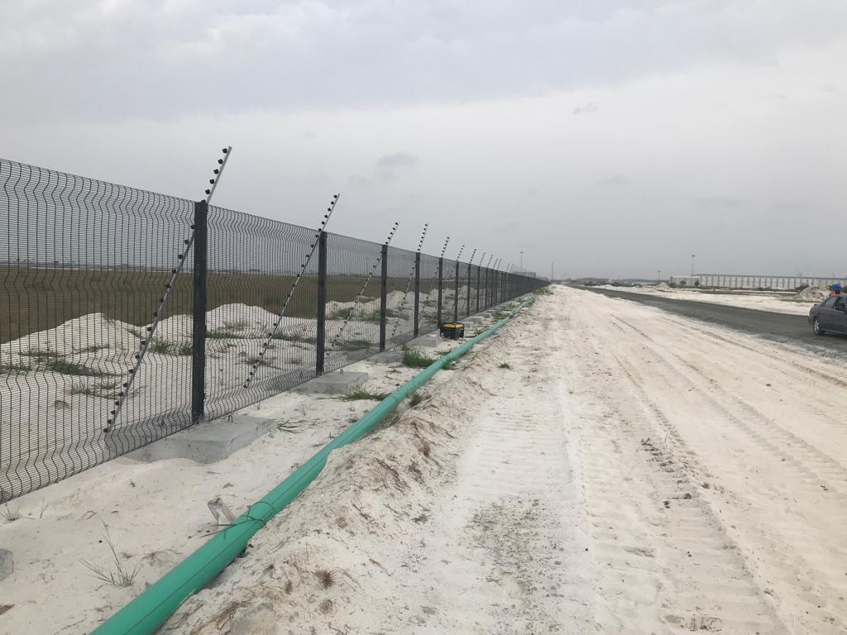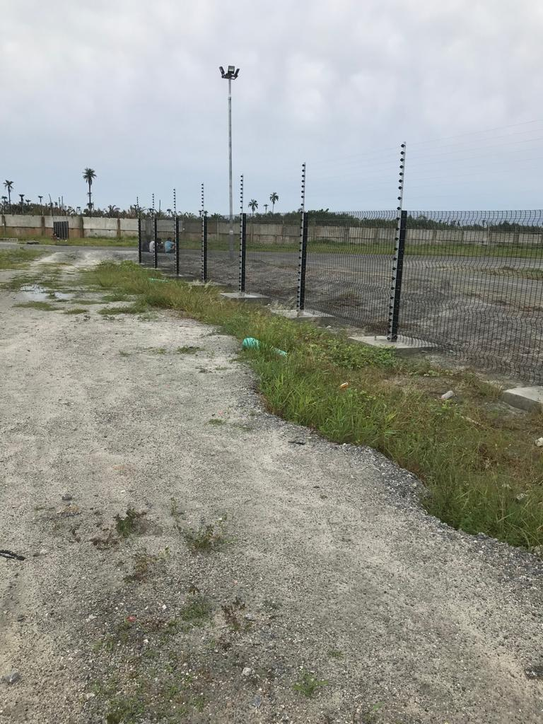**WE ARE CONSTRUCTION CONSULTANT**

We have deep knowledge and partnership with top foreign and local construction firms that provide us with state of the art equipment and materials.

**WE ARE PERIMETER BARRIER CONSULTANT**

We are seasoned professionals in the emerging use of barrier fencing

**WE ARE FACILITY MANAGEMENT CONSULTANT**

We offer facility management consulting and training for intending facility managers, both individual and corporately.



Plot 1, Mobalaji Ajasa Oluwa Close.

Fidiso Estate, Abijo-Ajah, Lagos, Nigeria

08180148469

08159345557

Is601services@gmail.com